IMPORTANT: Before you do anything else, please save a new copy of this document with your Group Number in the file name!!! When you finish, make sure to save this as a PDF and upload it to Canvas.

Group Number:

Group Member Names:

SARS-CoV-2 Mutation Mapping

Group Discussion Questions

Before we start plotting data…

- (2 points) Provide a definition for each of the following common types of mutations. In addition, provide an example of each type of mutation. If the mutation changes an amino acid, show how it does so in your example (you can find a codon table in the “Resources” section below).
  - Missense mutation:
    - Definition: nucleotide substitution that changes the identity of the codon from one amino acid to another
    - Example: TTA (AAU) -> GTA (CAU); Asparagine -> histidine
(or any other reasonable example, there are many)

  - Nonsense mutation:
    - Definition: nucleotide substitution that changes the identity of the codon from an amino acid to a stop codon
    - Example: ACG (UGC) -> AAG (UUC); Cysteine -> stop
(or any other reasonable example, there are many)

  - Silent mutation:
    - Definition: nucleotide substitution that does not change the amino acid coded for
    - Example: AAA (UUU) -> AAG (UUC); both encode phenylalanine
(or any other reasonable example, there are many)

  - Frameshift mutation:
    - Definition: changes reading frame so all amino acids after it may be miscoded
    - Example: AAC… -> AAA C… This changes an asparagine to a lysine and then everything else after changes.
(or any other reasonable example, there are many)

- (0.5 points) Which kind of mutation (of the 4 we just defined) do you think is most commonly found in a wild population, point mutations or frameshift mutations? Why?

Point mutations are the most common and may come from replication errors or mutagens. They’ll find this answer if they Google and may or may not expect it. Grade on completion.

- (0.5 points) Which kind of point mutations do you think are most common? Why?

Missense mutations because they are the most mathematically likely if you look at a codon table.

Now we’ll start working with the whole genome data…
- (0.5 points) How many mutations are in the UPenn database? Hint: take the number of rows of data and subtract 1 (for the header of the table).

The data is 68674 rows x 14 columns. Subtract 1 row for a header and get 68673 mutations/variants total.
- (0.5 point) Based on the data presented, which point mutation class is most common?

Missense mutations are most common

- (1 points) There are two general types of nucleotide substitutions, transitions and transversions. What is the difference between the two?
Transitions occur when one purine is exchanged for another purine or when one pyrimidine is exchanged for another pyrimidine. Transversions occur when a purine is switched for a pyrimidine or vice versa.

- (0.5 points) What is the GC content of SARS-CoV-2? You’ll have to look this up. An approximate number is ok.

~38% (if they round to 40% that’s also ok)

- (0.5 points) How does the SARS-CoV-2 genome GC content compare to the GC content of a human genome?

Human: ~41%, varies from 30-60% across genome
SARS-CoV-2 has fewer Gs and Cs
- (1 point) Why do you think there are so many C → T nucleotide substitutions?
A deaminated C is a U. U looks like and acts like T. This causes error repair to treat it like a T, which then becomes fixed in that population.

- (0.5 point) What is the most common nucleotide substitution that creates a missense mutation? Does this align with the most common type of substitution overall?

C🡪 T is most common for missense and overall

- (0.5 points) What is the size of the SARS-CoV-2 genome (approximately)?
29.8-29.9 kbp (~30 kb)
- (1 point) What do you see when you look at the distribution of mutations across the whole genome?
- Mutations have varying frequencies
- There are mutations across the whole genome, but mutations are not distributed totally evenly

- (1 point) What else would you like to know about these mutations or the virus they came from?
- Anything is acceptable. Just looking for curious answers.
- Many may ask whether these mutations have any affect on the virus’ lifestyle, infectivity, etc.

Now let’s look at individual genes…

S gene (Spike)

- (1 point) What is the function of the S gene?
- Found on the surface of the virus
- Binds to host cell receptors such as ACE2
- Initiates the infection process
- (1 point) What do you see when you look at the distribution of mutations across the S gene?
Similar to mutations across the genome, there are mutations throughout, but they are not even

- (1 points) Does this give you any ideas about what parts of the S gene are more important than others?
Areas with fewer mutations might be more important for function (any changes break them)

If there is time (E gene [Envelope], M gene [Matrix], or N gene [nucleocapsid]):

- (1 point) What is the function?
Varies. For example (E) Found in the virus envelope. It helps with assembly and budding of newly made viruses.

- (1 point) Consider questions 15 and 16, but now in the context of E, not S. Do your answers change? Why or why not?
Similar answer, however this is a shorter gene and you can see the unevenness a bit easier.

Extra Resources

Codon Table
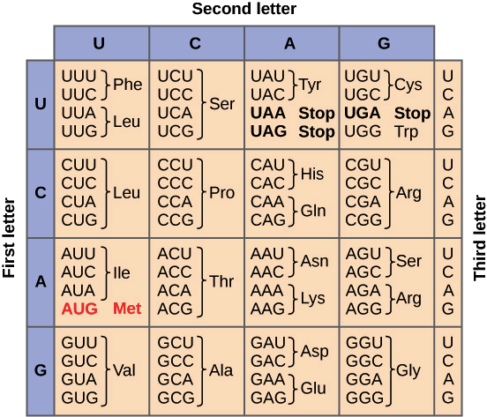
This Khan Academy link has a refresher on how to use a codon table.

Common Mutations

OpenStax Microbiology 11.5: Mutations link

Figures from the presentation

Rplot01: Barplot of each mutation class in the file
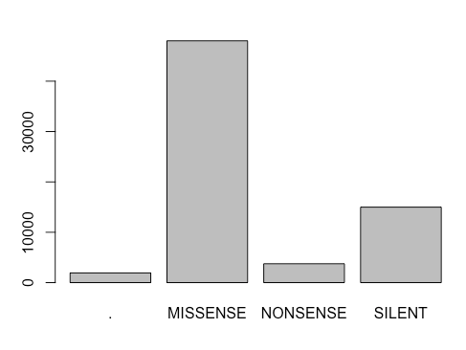

Rplot02: Barplot of each nucleotide change in decreasing order

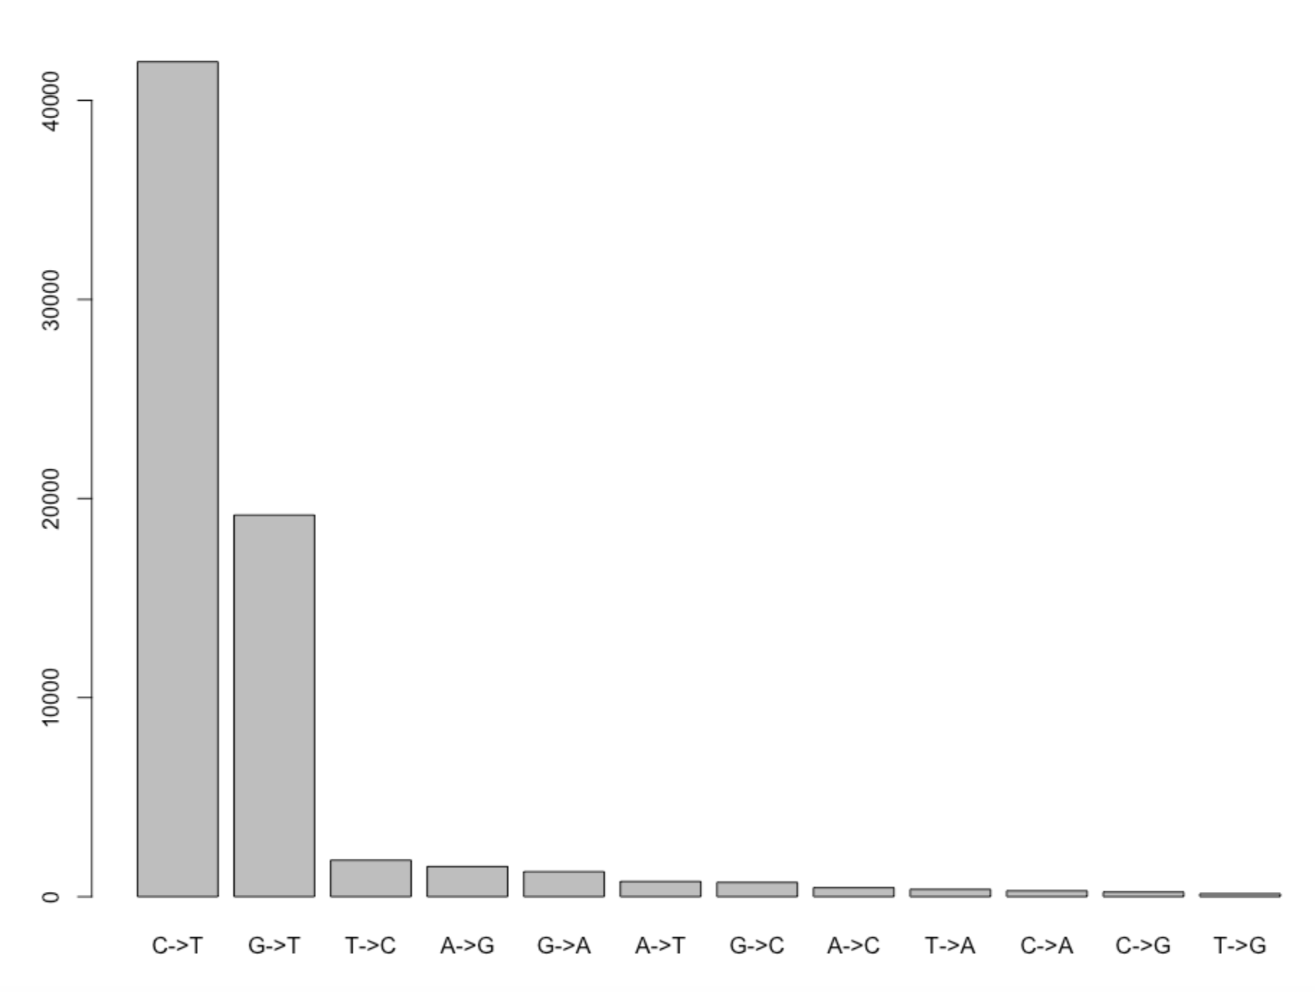

Rplot03: Barplot of each nucleotide change that causes a missense mutation in decreasing order

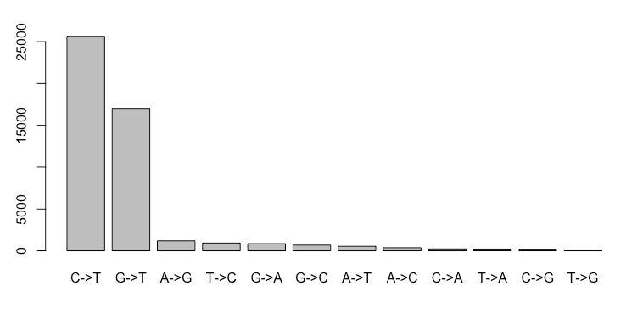

Rplot04: Mutations along the SARS-CoV-2 genome
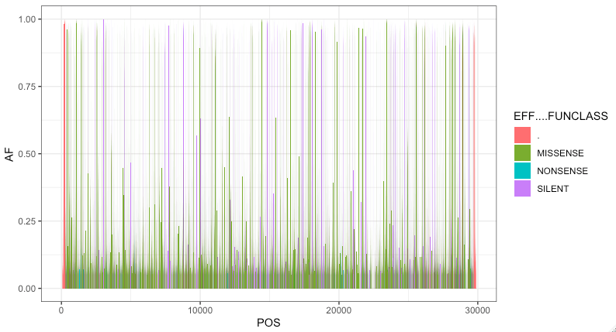

Rplot05: Mutations and genes along the SARS-CoV-2 genome
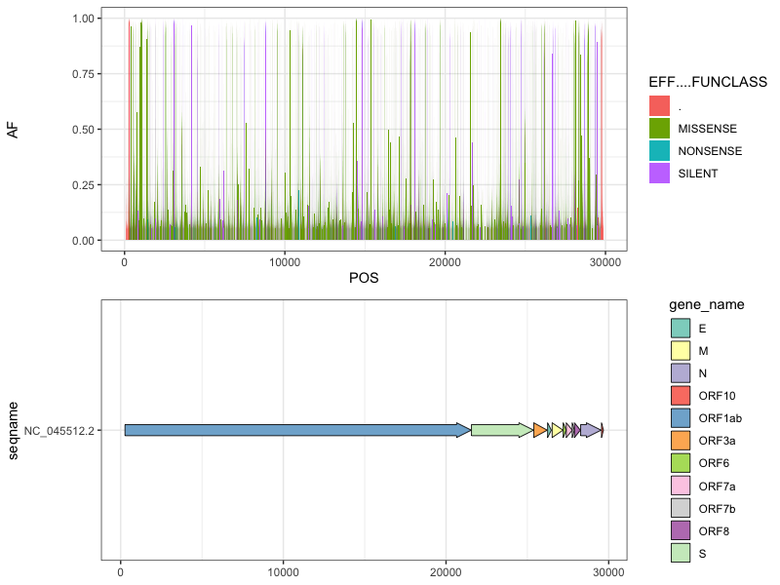

Rplot06: Mutations along the S gene
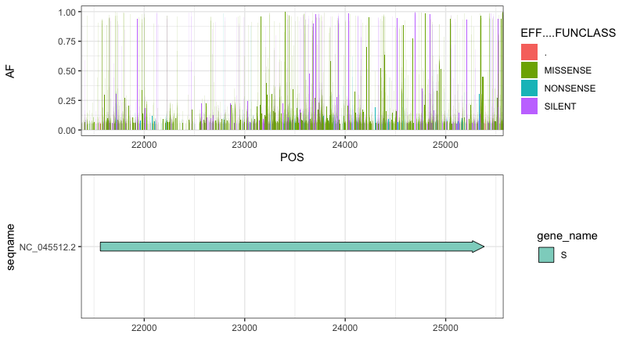

Rplot07: Mutations along the E gene
